TOMATIN, THE STRATHDEARN

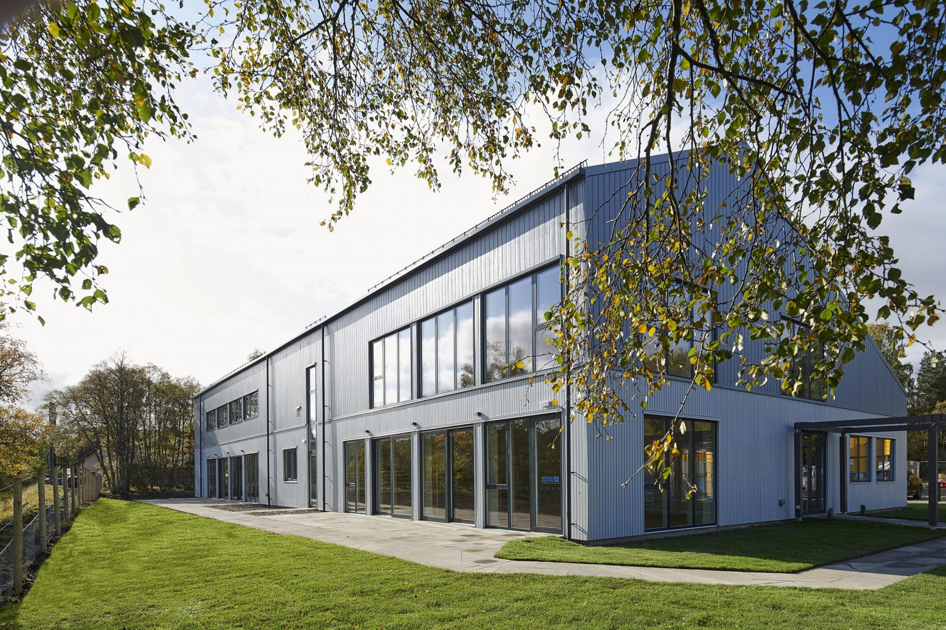

Aug 2021 Mick Andrew
General Information
Address: The Strathdearn, Tomatin, Highland IV13 7YN
01808 511700 https://thestrathdearn.org/ Venue is staffed.
- Venue on east side of road through Tomatin in village centre,
close to the A9
Car park at venue
- Built 2020
- Capacity of An Balvraid auditorium up to 180, padded stacking chairs.
- Mobile reception reasonable. Wi-fi at venue.
- Tomatin has community shop next to venue, whisky distillery visitor centre, café at venue and B&B/Guest Houses. Hotels in Carrbridge (7 miles), Petrol, Bank & cashpoint at Aviemore (10 miles). Other services in Inverness (16 miles).

Hall Details (An Balvraid Auditorium)
- Hall Dimensions: 17.3M (56’9”) long x 10.2M (33’6”) wide. Height at side walls & roof trusses approx 5.5M (18’). Roof X- section A-frame with 5 wooden roof trusses.
- Staging available 6 sections of 2M x 1M rostra @ 0.5M height. No Wings or Crossover, Treads available.
- Décor: Floor wood laminate with Badminton Court markings; Walls pine clad lower, white upper with white roof & wood roof trusses.
- Get-in: along outside of building then via double doors into store and double doors into hall. Straight, flat, approx 25M from van loading area to stage space. May be possible to get small vans nearer doors.
- Acoustics unknown.
- Blackout none. East side wall is largely windows with skylights in roof.
- Heating underfloor by ground source heat exchange system.
- Smoke detectors no info.
- Access equipment unknown.
Technical
- Power: assumed to be 100a 3-phase incomer. Twin 13a sockets throughout hall.
- Stage lighting unknown.
- Small PA system available – wall mounted speakers, radio mics. Induction loop available.
- Projection facilities (AV equipment and screen) in hall.
- Houselights are overhead LED strips, switched by hall entrance
Backstage
- Dressing rooms – various rooms can be used, also sports changing rooms with showers available.
- Kitchen available
- No separate toilets
- Café in hall complex.

