Dalbeattie Birchvale Theatre

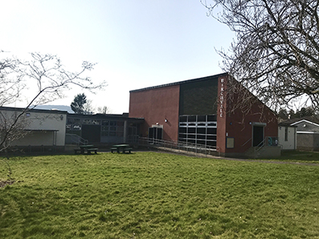
Mar 2022 Mick Andrew
General Information
Address: Birchvale, Maxwell St, Dalbeattie, Kirkcudbrightshire DG5 4AG.
Box Office 07717 676254. https://www.birchvale.scot/
- Venue is between Maxwell St and Maxwell Gardens, north of A711
just west of town centre. Car parking at venue.
- Built as primary school in 1970’s and converted in 2021-2.
- Capacity 72 fixed tip-up padded seats in 7 rows of raked seating.
- Mobile reception good for all networks.
- Dalbeattie has general stores, Post Office, cafes, hotels, garage and free-to-use cashpoint at Co-op. Nearest bank at Castle Douglas (5 miles). Other services Dumfries (15 miles).
Venue Details
- Stage: Proscenium opening 6.3M (20’8”) x 2.54M (8’4”) high. Depth from front edge to back blacks 4.2M (13’9”), to back wall 6.1M (20’). Wings 1M (3’3”) both sides (SR wing has indent for rear fire exit up stage). Crossover behind back drapes, 3 steps off front of stage across whole width.
- Décor: Stage has black box surround with dark navy blue FOH tabs and black mid & back stage tabs. Walls & ceiling dark navy blue, auditorium floor carpeted.
- Get-in: Via upstage shutter door 2.14M (7’) high x 1.98M (6’) wide at back of stage, up 6 steps, with right angle turn onto stage. Approx 15M from side roadway loading access.
- Acoustics good.
- Blackout perfect.
- Heating by radiators.
- No Piano. Smoke detectors above stage and in auditorium, possible to isolate.
- 7 step A-frame ladder available.
Technical
- Power: 100a 3-phase incomer in switch room off Stage Right. 4 x twin 13a sockets on stage (all single 13a sockets are switched from control room).
- Stage lighting grid above stage with DS & US cross truss & 5 up-down stage trusses @ 2.54M high. 3 x 8 circuit IWB’s across stage & FOH 8 circuit IWB LX bar. Zero88 FLX S48 LX desk in control room, 48 x Zero88 Chilli dimmers in room off stage right. 8 x 650w/500w profile spots FOH, 5 x 500w fresnels LX1 & 2 side bars of 4 Par 56 cans. 10 x 650w fresnels & 3 Par 64 cans also.
- Sound – Behringer X32 Compact digital mixer in control room, Yamaha PX3 & PX5 amps, 2 x RCF FOH speakers. No mics or DI boxes. Playback by laptop.
- Film projector & screen available.
- Houselights are switched roof lights operated from control room.
Backstage
- 1 Dressing room off stage right. Plans for 2nd room exist.
- Bar & Café space (Green Room) in venue available.
- Separate backstage toilet and plans for shower off dressing room.

