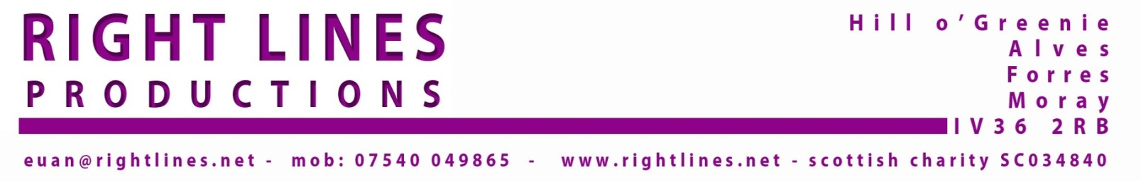
Rapid Departure
Scottish Tour – March 2016. 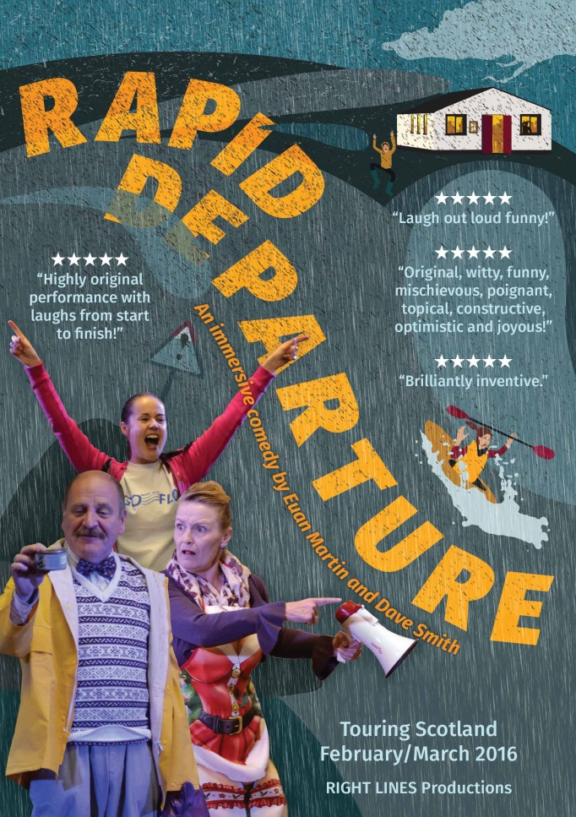

Introduction
The Rapid Departure project began in early 2014 with an application to Creative Scotland. Once the initial concept for the show had been settled upon, writers Euan Martin and Dave Smith determined to write and produce a brand new piece of interactive comedy theatre suitable for village hall touring. We were inspired to create a show set in a village hall during a flood where the audience members arrived to discover they were in fact evacuees forced to shelter in the local village hall Rest Centre until the flood waters abated. We were further inspired to approach the Scottish Environment Protection Agency (Sepa) to seek a sponsorship deal to add value to the project and we were delighted when they agreed to offer support. The project was given the go-ahead in autumn 2014 with full CS funding support, plus a sponsorship input from Sepa and further support from Arts & Business Scotland.
The show was written and produced and Rapid Departure toured Scotland in May/June 2015 to great public acclaim. The volume and quality of audience feedback was much greater than ever achieved on previous Right Lines tours, with 97% of the respondents (65% of total audience members) rating the show either 4 or 5 star.
Re-tour March 2016.
Sepa representative Stewart Prodger was very impressed with the outcome and the “soft marketing” opportunities presented by the agency’s involvement in this theatre production and he contacted Right Lines immediately after the end of the 2015 tour to indicate that Sepa would be interested in offering further support to the show. We were asked to prepare a budget based on a 3-week tour with a proposal to take Rapid Departure out again before the end of March 2016.
These negotiations resulted in Sepa delivering £30,000 in funding support. This was by far and away the most generous sponsorship arrangement ever secured by Right Lines. Despite the enormity of this sponsorship deal, we were slightly short of the minimum budget required to finance the re-tour. An application to Creative Scotland drew a positive response and an additional £8,000 completed the funding package.
Sponsor’s Requirements
As with the original production, Sepa made no request to influence the creative process with regard to content. However, there was a remit in relation to planning the tour. Right Lines was asked to target flood risk areas with a specific focus on Dumfries & Galloway, where new flood warning schemes were planned. The general aim of supporting the tour was to use theatre to help raise awareness of local initiatives and highlight Sepa’s nation-wide Floodline services, thus enhancing the general population’s preparedness for flooding events.
Right Lines’ normal approach to organising a tour involves contacting local promoters across the country to establish a range of bookings with a good geographical spread. With the exception of occasional self-promoted dates in our own local area in Moray, we do not, as a rule, hire venues ourselves and attempt to promote our shows “remotely” without the support of a local promoter on the ground or the marketing resources of larger venues.
Consequently, our strategy led us to contact existing Supported Touring Networks – North East Arts Touring (NEAT), Borders Live Touring (BLT) and The Touring Network, plus a new touring network in the process of being established by Dumfries & Galloway Arts Festival. Very quickly, we made a good connection with Peter Renwick and Louise Davies of Dumfries & Galloway Arts Festival and a 5 date tour of Dumfries & Galloway was arranged with their assistance. In fact, they selected the Rapid Departure tour as a “pilot” for their new supported touring scheme which is due to go live in September 2016 and also booked the show as the entertainment for the Arts Festival launch event on 2nd March 2016.
Creative Team
Appointment of Administrator – as with the 2015 tour, Lucy Conway was appointed to assist with booking accommodation during rehearsals and on tour.
Appointment of Director – Mark Saunders was once again confirmed as Director for the retour. Mark works full time at RCS but he secured the necessary cover to allow him to accept this freelance job.
Cast and Crew – as this retour was a relatively quick follow on from the original tour, we aimed to retain the same cast and crew to allow continuity and also to permit a shorter rehearsal period in the interests of budget restrictions. We managed to retain the services of actors Estrid Barton and James Bryce, plus our stage management team of Mick Andrew and Brian Gorman. Unfortunately, other work commitments prevented Helen Mackay, Ewan Donald and Barrie Hunter returning for the retour and so three cast members had to be replaced. The recasting was achieved through a mixture of previous working relationships, personal knowledge of specific actors and their qualities and experience, and approaches to casting agents. We did not hold formal auditions, but the writers and director were in consultation throughout the casting process and the director also held individual meetings and discussions with the actors. As a result, David Rankine, Ross Allan and Romana Abercromby joined the company.
Special effects – for the inaugural tour, we utilised the Sepa sponsorship funds to hire a film-maker, Tim Flood, to visit each venue on the tour to film aerial footage of the halls using a drone camera. This footage was processed by video-artist John McGeoch to add CGI effects which gave the impression that the local hall was completely surrounded by flood water. We also secured the services of a senior BBC Scotland Sound and lighting equipment was hired, purchased or drawn from RLP’s own resources.
Publicity Design – the Rapid Departure poster images and flyer were designed by Trish O’Grady, Pitlochry. The original image was reworked for the retour and 1000 A4 posters were produced, plus 5000 A5 flyers with details of the first 2 weeks of the tour and 500 A5 flyers specifically for the D&G leg of the tour. These posters and flyers were distributed to all venues and e-flyers were also available and were sent to all promoters, press and company contacts. The tour details were displayed on the Right Lines website and Facebook page, venue websites and social media platforms, plus D&G Arts Festival marketing sites. The Creative Scotland logo and the Floodline logo featured prominently on all publicity material.
Accessibility – expert advice was sought from Kinny Gardner, a theatre professional who has extensive experience delivering theatre to people with hearing impairment. As a result, a synopsis of the show was prepared and was available in booklet form and copies were available at all venues on the tour.
General Admin and Publicity – Day to day administration of the retour project was undertaken by Euan Martin. Press releases for different areas were prepared and issued to local and national press. Local and national radio and TV were contacted and several interviews took place, with the show being featured on BBC Radio Scotland programmes. A variety of local newspapers and websites carried articles on the production.
Actual Flooding Events
The main objective underpinning Sepa’s decision to sponsor the retour of Rapid Departure, was to raise the profile of Floodline and promote preparedness for flooding events across Scotland. In booking the tour, the request was to target “Potentially Vulnerable Areas” (PVAs) as designated by Sepa – in other words, towns or villages at risk of being affected by flooding. After a great deal of effort and negotiation – much more than we would normally anticipate – the tour schedule was achieved by mid-December 2015 with 16 dates in place.
Neither Sepa nor Right Lines could have anticipated that December 2015 and January 2016 would see flooding events on an unprecedented scale across the whole country and at a very late stage in the planning process, we had to take steps to rearrange some dates. We had a booking in Comrie, but the local promoter decided to cancel on 30th December, as she advised that the hall where the play was due to visit was being sandbagged. We also had two bookings in Aberdeenshire, but given the devastating impact in that area, Sepa took the decision that we could not proceed with the performances.
Unfortunately, these cancellations came after the flyers had been printed. They also came so late that it was impossible to rebook the show in other venues. We did manage to replace the Comrie date with a performance at The Dunblane Centre, but the Aberdeenshire dates could not be replaced and a proposed gig in Bridge of Allan failed to be confirmed, again due to actual flooding concerns. As a consequence, our planned tour of a minimum 15 dates was reduced to 13. This was entirely beyond Right Lines’ control and without question, entirely as a result of severe weather conditions on a level never previously experienced.
The irony of this situation did not escape us: we were touring a play with flooding as a central theme, with heightening the awareness of Sepa’s warning systems as an underlying message of the project. However, the reality of the situation across Scotland as a result of the actual flooding meant that it was impossible to avoid being aware of the impact of such devastating weather episodes.
In fact, we changed very little by way of amendments to the script in the light of the terrible weather conditions, but we decided to modify the CGI element to avoid showing film clips of the actual village halls we were performing in, as we had done on the first tour. This made no difference to audience members who had not seen the original version of the show and were therefore not expecting it, but it did mean we had to forego the opportunity for a “wow factor”. However, the idea of images of village halls with “mock” flood water lapping round them was not so amusing after the winter floods. This kind of image, filmed from drone cameras, was a nightly illustration on TV news programmes of the real and actual devastation caused by the flooding.
Adverse publicity
Sepa also engaged in publicity of Rapid Departure through their own channels. One of their partners, Neighbourhood Watch, prematurely released an email notification about the show without final agreement and sign-off from Sepa’s media officer and this resulted in some adverse publicity. A front page headline in the Dundee Courier “Residents’ Outrage at Flood Comedy Invite” referred to a story that some residents in Alyth in Perthshire were upset that they had been sent an email inviting them to a comedy theatre show about flooding when their town had suffered serious flooding in July 2015. Of course, not mentioned was the detail that we had deliberately avoided playing in Alyth, or anywhere nearby for the very reason that we may have faced accusations of insensitivity.

Acknowledgement Slip
By way of acknowledging the special circumstances at the time of our tour, we prepared a brief statement which was distributed to all members of the audience as they arrived at venues:
Thank you for coming to the show.
Rapid Departure was conceived and written 18 months ago and toured for the first time in May/June 2015.
Right Lines would like to take this opportunity to say that we appreciate that many of you attending tonight may have suffered greatly from the recent flooding.
Our intention has been to explore the issues surrounding flooding and celebrate the resilience and strength of communities and to entertain those same communities through an evening of comedy theatre.
We hope that you will enjoy our show in the spirit in which it has been created.

Rehearsals
Rehearsals took place at Vivace Theatre Studios, Sauchiehall St, Glasgow for one week, followed by a second week at the National Theatre of Scotland rehearsal rooms at Civic House, Glasgow. Vivace was an adequate space for the first week of rehearsals, although slightly haphazard in terms of co-ordinating our arrival and ensuring we were in the correct studio. However, the benefits of being a very central location and offering a reasonable financial deal outweighed the negatives.
The production week at NTS was excellent. The staff could not have been more welcoming or helpful and this was a really positive experience. We were in the building on the day of the 10th anniversary of the start of NTS and some company members were even invited to join staff at their “birthday party”. We held a preview/dress rehearsal on Friday 26th February with a small number of invited audience members, including some Sepa staff. This allowed the company to work with a live audience for the first time.
Tour – 16th May – 6th June 2015.
The opening night of the tour took place at The Dunblane Centre, Dunblane on Saturday 27th February. This was a hurriedly organised replacement for the Comrie date and achieved a relatively small, but very enthusiastic audience who all rated the show a 5-star performance.
The first week on the road involved a very successful visit to Cove Burgh Hall 1st March; Loch Arthur, near Dumfries on 2nd March was the next date, where we participated in the launch of the D&G Arts Festival’s annual programme. This was not an “open to the public event”, but rather a showcase in advance of the 5-date tour about to take place in Dumfries & Galloway. After the official launch event, delegates (including board members, sponsors, promoters, media and a representative from Creative Scotland) moved to a village hall-type space for a performance of the show. The following day involved a long drive to Findhorn where a sell-out crowd at The James Milne Institute returned another 100% 5-star rating!
The second week began on Wednesday 9th March in Galashiels at MacArts. A reasonable audience of 45 enjoyed the show, but problems with the heating system meant it was noisy in the first half of the show and cold towards the end when they system was shut off!
Oxnam on 10th March was the perfect village hall setting with a very attentive committee and home bakes that really impressed the cast and crew. The show was well-received by the 43-strong audience. The next night was at The Brunton, Musselburgh with a full house of 107. The final date of the week was at McKillop Hall, Lochwinnoch as a contribution to the local Arts Festival programme. The show was again very well-received here with a large audience of 84.
The final week saw visits to Moniaive, Colvend, Kirkcudbright and Wigtown in Dumfries & Galloway. Sadly, at the last minute, the Stranraer date was cancelled due to lack of pre-sales. We made it clear we would prefer to do the gig, but D&G Arts Festival decided it was better to cancel rather than have a very small (or non-existent) audience. The reason for this unexpected lack of interest in the show was not immediately apparent, as the event was well-advertised and all the usual marketing methods were employed.
Of the 12 dates on the tour, we visited 10 venues for the first time and the visits to Cove Burgh Hall and The Brunton were secured on the back of the reputation of the company following previous bookings at these venues.
Reviews
We attracted reviews from Joyce McMillan from The Scotsman - “…the dialogue bristles with cheeky, well-crafted one-liners…” and Paul Cockburn from Broadway Baby – “All in all, this is an energetic, entertaining and thought-provoking story that never forgets where its dramatic heart should be.”
Full Reviews – http://www.scotsman.com/lifestyle/culture/theatre/theatre-review-rapid-departure-macarts-galashiels-1-4059978
http://www.broadwaybaby.com/shows/rapid-departure/710987
Artistic Quality
We were able to attain a high standard of artistic quality in terms of the script-writing and directing by employing experienced theatre professionals to undertake these tasks. By employing well-established actors, plus the above-mentioned production team, we were able to achieve the high standard of performance and production that we have attained with previous touring shows. Right Lines offers good wage rates, all above the Equity minimum, plus an attractive package of touring allowances, accommodation and transport arranged and pre-paid by the company. As a result, we were able to contract a talented team who formed a strong bond and worked extremely well together. We believe that by looking after our team well and by offering good pay and conditions, the challenges of rural touring are accommodated more easily and the result is a hard-working, contented team.
Public Benefit & Demand
The response to the retour of Rapid Departure from audiences at all venues was universally positive and definitely fulfilled our main aim of providing people with “a good night out”. Eight venues were sold out and the remaining four venues were more than ½ - ¾ full with good, appreciative good audiences.
We did not seek audience feedback by requesting the completion of a written form. On this occasion, we opted for a fun approach and asked audiences to rate the show by placing their “Rest Centre” lanyards in either the 5-star, 4-star or 3-star bucket as they departed. At 8 venues we achieved a 100% return in the 5-star bucket! Once again, a commonly heard comment was “we need more shows like Rapid Departure”, or “will you come back again?”
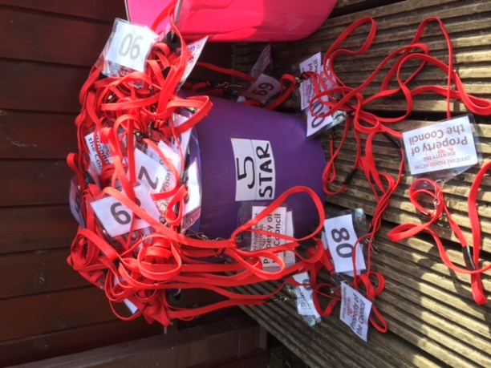

Publicity and Marketing
As noted above, the posters and flyers for the tour were designed by Trish O’Grady, a freelance graphic designer who also produced the image for Whisky Kisses at Pitlochry Festival Theatre. 1000 A4 posters were produced, plus 5000 A5 flyers with details of the first 2 weeks of the tour and 500 A5 flyers specifically for the D&G leg of the tour. These were distributed to venues and promoters. We did not print a show programme, but created an online programme, available at the company website.
The same image was used for an e-flyer which was circulated to email contact lists by Right Lines, cast, crew and everyone else associated with the project.

Facebook & Social Media
Right Lines used Facebook and Twitter as marketing tools and several messages of support and comments on the show were left on the Facebook page (RightLinesPro) and Twitter (RightLinesPro). Rehearsal and production photos were also uploaded onto the Facebook page.
Acknowledgement of Funders
Right Lines Productions is extremely grateful to all funders, sponsors and supporters who have combined to make this production and retour both a reality and a tremendous success. In particular, The Scottish Environment Protection Agency (SEPA) for the extremely generous sponsorship support and Creative Scotland for the Quality Arts Productions award which helped complete the funding package.
All publicity and press releases, plus the company website and Facebook page featured logos and indicated that the production was supported by SEPA and Creative Scotland. In addition, we included the SEPA Floodline logo on the flyers and featured the Floodline contact number in the “news report” during the show. At the conclusion of each show, we distributed a copy of the SEPA Floodline information leaflet and, for PR purposes, we also provided audience members with a free gift – a copy of “Distilling Whisky Kisses”, the book we prepared to coincide with Whisky Kisses at Pitlochry Festival Theatre. This not only describes the making of a new Scottish Musical, but also contains the history of Right Lines Productions.

Quotes
"If laughter really is the best medicine, Right Lines should be available on prescription." Ruth Wishart, Cove Burgh Hall Events Team.

"Awesome show... loved it so much I wanted to be in it! Seriously, a great, must-see piece of theatre." Andrea Medd, Dumfries & Galloway Arts Festival.
“I'm just back from the launch of the Dumfries and Galloway Arts Festival programme at Loch Arthur: it's a really exciting and diverse series of events and shows, some local to Moniaive. And especially exciting was the preview performance of Rapid Departure, the play that will be staged in the Glencairn Memorial Institute on Tuesday 15th March at 7.30pm. Tell everyone you know to get down to Watsons (or the Midsteeple) to get their tickets, because it is a great night's entertainment. It's hilarious - I haven't laughed so much in a long time - and it is also poignant, with a strong but not overstated environmental message. And it's engaging and participatory, in a gentle and undemanding way. Any concerns we might have had about staging a play about flooding after the recent floods are unfounded. The actors handle that in a very sensitive and entertaining way. So let’s get people through the doors for a good Festival Village night.”
Peter Roberts, Promoter Moniaive.
Project Assessment
The March 2016 tour of Rapid Departure has been a successful project which we believe has been organised with skill and professionalism. Without question, the subject matter of our flood-based play has made the delivery of the production a challenging project due to the exceptional weather conditions in the weeks prior to the start of the tour. We believe we have managed to overcome the obstacles of adverse publicity and public mis-conception (in some areas) of the intentions of the play. There is absolutely no doubt that the last thing we aimed to do was upset people or make fun of those who had suffered as a result of flooding events. As we had hoped, Right Lines has demonstrated that the company is capable of securing adequate funding to write, produce and tour new theatre to target audiences and deliver a show of high artistic quality on time and on budget.
One of the main aims of this retour was to target new audiences in new areas of the country. We feel we were successful in this aim and the production appealed to our new audiences in the Borders, Dumfries & Galloway, Dunblane and Lochwinnoch. The warmth of the response from promoters and audience members in these venues new to Right Lines Productions suggests that we have successfully gained new supporters and have raised the profile of the company right across Scotland. Consequently, we believe we have satisfactorily fulfilled the criteria set by the project funders at the same time as maintaining our commitment to making and delivering original and innovative theatre.
Euan Martin. Right Lines Productions – May 2016.

