PRESS RELEASE

From These Parts

Right Lines Productions
From These Parts is a Scottish alien abduction comedy that explores the changing population in the Highlands - and what it means to be local in a cosmic context.
The latest theatre production from Right Lines will be a fast moving four-hander comedy that examines the issue of migration to and from the Highlands on local, national and intergalactic levels! We ask the questions - why do people come, why do people stay and why do they go? Furthermore, what exactly does it mean to be a local?

Following a one-off UFO experience, Jack has been pursuing his passion for all things extraterrestrial for years. He has joined an online community of fellow enthusiasts and they have given him the task of building an Intergalactic Communicator to establish Contact. Only his day job as a garage mechanic in a remote Highland village and the influence of his level-headed daughter Mhairi have prevented him from spending all his time reaching out to commune with life beyond the stars.
Mhairi has kept the business going, just, but now the planets are perfectly aligned and the day of the Big Test is approaching...

Into Jack’s world happens Felicity, moving to the area to escape a marriage and establish a Healing Centre. Her city-slicker son Darren plans to stay only long enough to drop his mother off before racing back to the South in his extremely expensive sports car.
However, the car breaks down outside the garage at exactly the same time as Jack realises the long-awaited final component for his Communicator device doesn’t fit. He needs to find a replacement part quickly to finish his machine… and where on earth can he find it?

As the lives of these four individuals collide, is this a calamity or good fortune for all concerned. Or both? And what are those strange lights in the night sky…?

From These Parts will feature a very strong cast: Ron Emslie, Vari Sylvester, Helen Mackay and Ewan Donald. The Director is Ian Grieve, Set Design by Mike Taylor and Michael Start and the Writers are Euan Martin and Dave Smith.

“We are very fortunate to have the services of Ron Emslie once again. He has worked with Right Lines on several shows including Who Bares Wins, Watching Bluebottles and Whisky Kisses. In fact, it was through Whisky Kisses that Director Ian Grieve met Ron and promptly cast him in the lead role of Willy Loman in the highly-acclaimed Perth Theatre production of Death of a Salesman in 2011. Coincidentally, Vari and Ewan were also in Death of a Salesman and From These Parts is the first time they have all been reunited with Ian Grieve since then.”
Helen Mackay from Caithness makes up the acting contingent. Helen has also worked with Right Lines previously in The Accidental Death of an Accordionist and alongside Ron Emslie in the online radio comedy Morrison’s Van which is still available to download on the Northings website.

From These Parts is funded by the Northern Scottish Touring Fund and will tour to venues across the Highlands & Islands and North-East of Scotland in June 2012.

For this production, we are collaborating with two new artists on Set Design. We enlisted Tain artist Mike Taylor whose work ranges from the most detailed trompe l’oeil to full-scale murals on the side of the Greenpeace Rainbow Warrior. Through connections in the Moray Arts community, Euan met up with Michael Start from The House of Automata in Kinloss. Michael is a world expert on horology and Automata and he was the expert advisor to Martin Scorsese on the recent Oscar-winning Hollywood movie “Hugo”.
“As the main character in our play is building an Intergalactic Communicator, I thought Michael would be the ideal person to help us design and build this essential centre-piece to our production. Despite a very busy schedule, including a major contribution to the Daniel Radcliffe film “The Woman in Black” and appearances at the Brit Awards and on Britain’s Got Talent with his Flea Circus, Michael agreed to work with us. Having an advisor to an Oscar-winning movie is a fantastic addition to our Creative Team, as well as a great career move for Michael, obviously!”

Right Lines Productions will tour From These Parts in the Highlands, North-East and Western Isles between 16th – 30th June 2012.

For further information, please contact Euan Martin at euan@rightlines.net or visit the following websites:

Right Lines – www.rightlines.net
NSTF - www.nxne.info
Northings – www.northings.com
House of Automata – www.automatomania.co.uk

Euan Martin, Right Lines Productions www.rightlines.net 07540 049865.

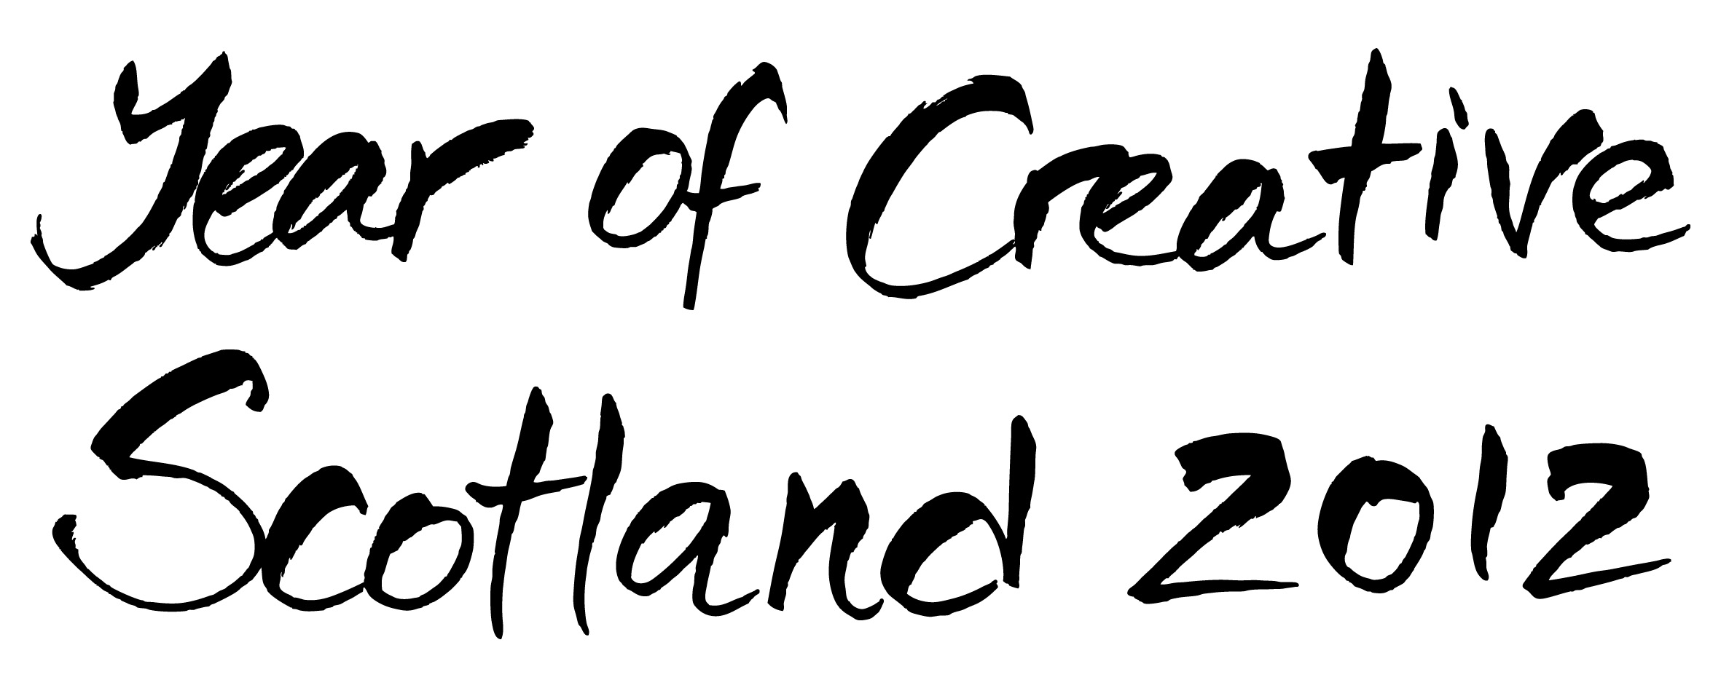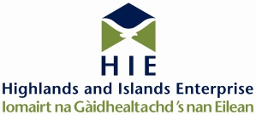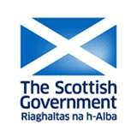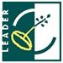

THIS PROJECT IS BEING PART-FINANCED BY THE SCOTTISH GOVERNMENT AND THE EUROPEAN COMMUNITY HIGHLAND LEADER, CAIRNGORMS LOCAL ACTION GROUP LEADER, RURAL ABERDEENSHIRE LEADER, MORAY LEADER and OUTER HEBRIDES LEADER 2007- 2013 PROGRAMMES.

